Setting up a Blockchain Business Network Running in Multiple Physical Machine
Downloading the source code and making required changes
Step One: Clone the source code from the github link below:

https://github.com/varun-raj/fabric-dev-servers-multipeer

Step Two: Configuring the number of peer nodes in crypto-config.yaml file -:

OrdererOrgs:
- Name: Orderer
Domain: example.com
Specs:
- Hostname: orderer
PeerOrgs:
- Name: Org1
Domain: org1.example.com
Template:
Count: 3
Users:
Count: 0

Step Three: Configuring the orderer in configtx.yaml file, change the orderer.example.com to the Ip address of the PC 1 (PC running “startFabric.sh” file in the network”) -:

Orderer: &OrdererDefaults
OrdererType: solo
Addresses:
# - orderer.example.com:7050
- 193.168.0.199:7050

Step Four: Open the “composer” folder of the project in the terminal and Run the “howtobuild.sh” script for creating new certificates, genesis block and channel transaction file -:

Step Five: Open the “docker-compose.yml” file in the composer folder and change CA keyfile with the most recently creaetd keyfile in the folder location
i) Copy the key file name from the folder give below:
{project directory}/crypto-config/peerOrganizations/org1.example.com/ca/

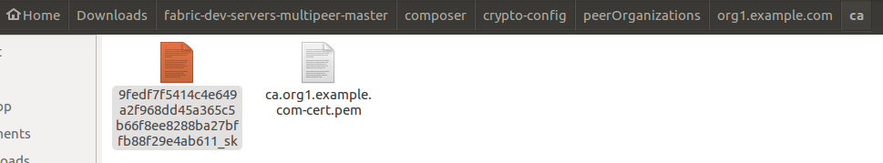
ii) Paste the copied name of the file in the command section of the ca.org1.example.com service in the “docker-compose.yml” file
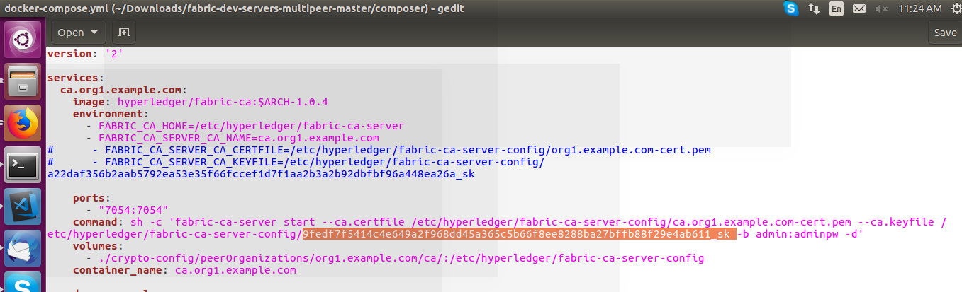
Step Six: Configuring the createPeerAdminCard.sh file:
i) Change the ip address of the peer2 node in the temporary connection.json in the “createPeerAdminCard.sh” script with the ip address of the PC2 (systems running the startFabric-Peer2.sh”)
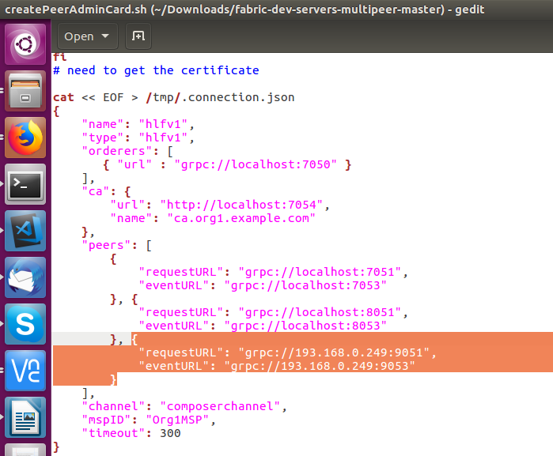

ii) Changing the Admin user keyfile name in the “createPeerAdminCard.sh” file
1) Copy the name of the most recently created keyfile in the folder location -:

{project directory}/composer/crypto-config/peerOrganizations/org1.example.com/users/Admin@org1.example.com/msp/keystore/
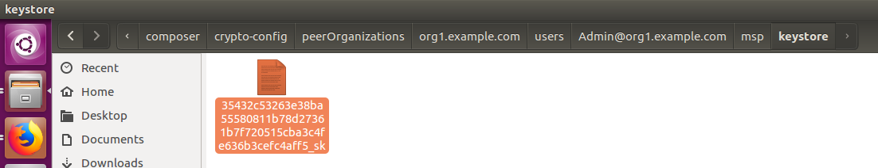
2) Paste the file name in the “PRIVATE_KEY” field of the “createPeerAdminCard.sh” file as below -:
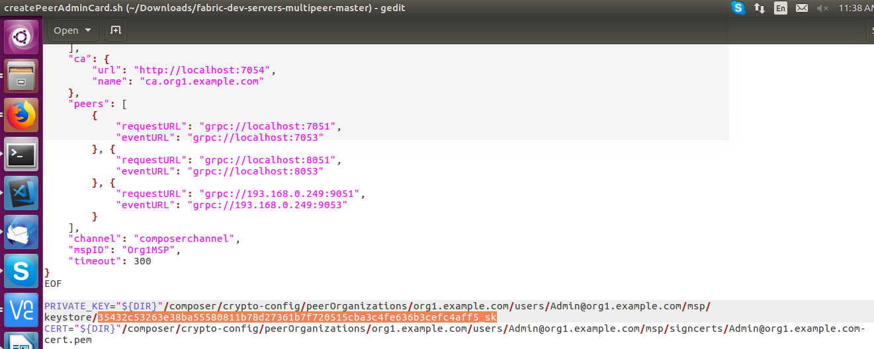

Step Seven: Change the “orderer.example.com” with ip address of the PC1 in the startFabric-Peer.sh file in the project folder -:
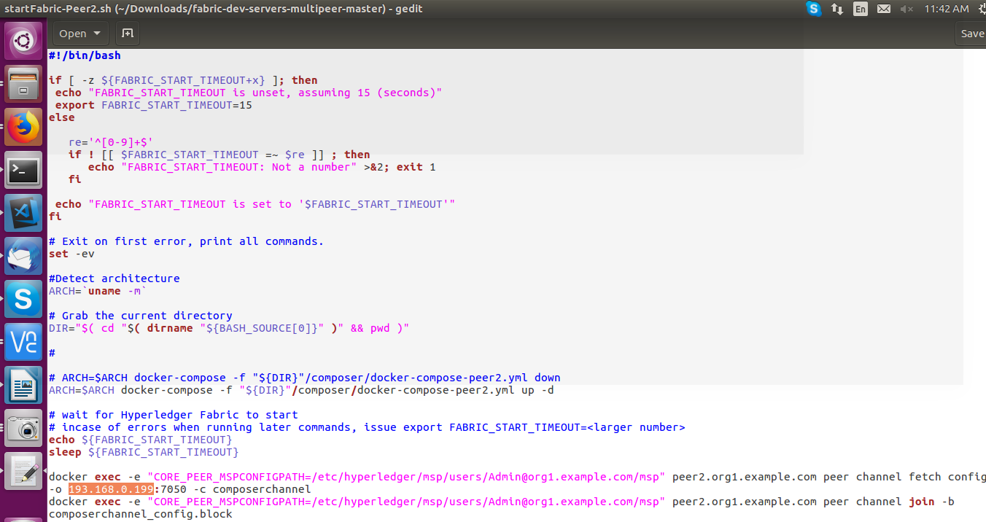

Creating the Hyperledger Fabric network with three Peer nodes, Two nodes running on PC1 and one node running on PC2.

ON PC 1

Step One: Run the “startFabric.sh” file in the terminal of PC1
It should create :
Two peer nodes: peer0.org1.example.com and peer1.org1.example.com
One orderer node: orderer.example.com
One Certificated authority: ca.org1.example.com
Two couchdb container: couchdb and couchdb1

Run command “docker ps” in the terminal it should give the following output
It should also create a channel and should connect the peer nodes to the channel, after running the “startFabric.sh” file look for the logs in the terminal showing below:
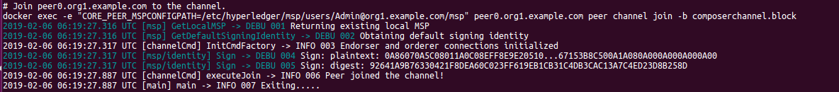
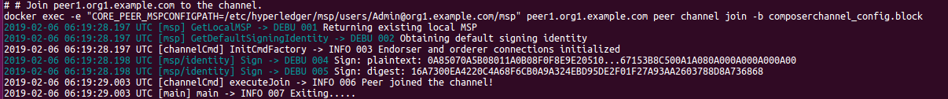
It makes sure the peer nodes were created and successfully connected to the channel

ON PC 2

Step Two: Run the “startFabric-Peer2.sh” script in the terminal of the PC2 in the source code folder -:
It should create:
One peer node: peer2.org1.example.com
One couchdb container: couchdb2
Run command “docker ps” in the terminal it should give the following output:
Also it should join the peer2.org1.example.com node to the channel created in PC1, look for the following logs in the terminal to make sure the connection was made:

ON PC 1

Step Three: Creating network card on PC 1 -:
i) First remove any networkcards in the composer by running the following commands -:
rm -rf ~/.composer
ii) Run the following command to make sure there are no other network cards in composer -:
composer card list
It should give the following output
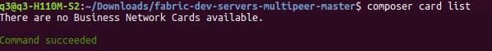

iii) Run the “createPeerAdminCard.sh” script in the terminal of the PC1 -:
It should create and import the a network card with name “PeerAdmin@hflv1” and import it in the composer wallet
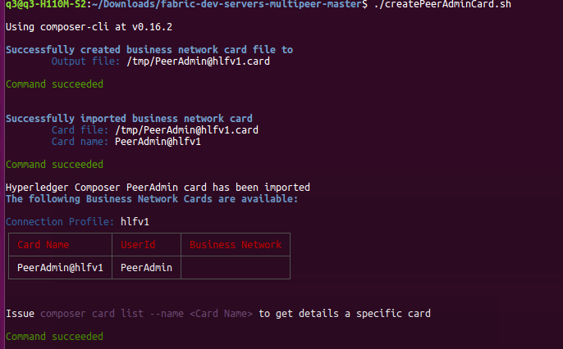

Deploy the Business Network Archive file on the Fabric

Step One: Installing composer runtime on fabric network,
run the following command in the terminal -:
composer runtime install --card PeerAdmin@hlfv1 --businessNetworkName test-bank

It should install the composer runtime on the network with give name, in this case “test-bank”
Step Two: Deploy the business network,
i) change to the folder in which created bna file is located or put the bna file in the current folder
ii) Run the following command -:
composer network start --card PeerAdmin@hlfv1 --networkAdmin admin --networkAdminEnrollSecret adminpw --archiveFile test-bank@0.0.1.bna --file networkadmin.card

It should start out business network from archive file, i.e. test-bank@0.0.1.bna file, on the fabric network.
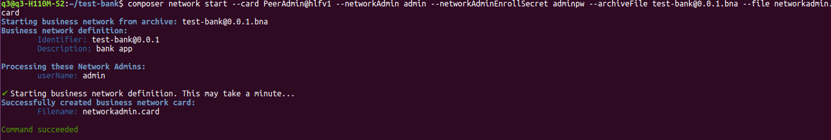
Hence our business network is created running with business logic.

Step Three: Import the network administrator identity as a usable business network card
composer card import --file networkadmin.card
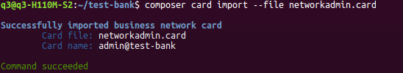

Step Four: To check that the business network has been deployed successfully, run the following command to ping the network:
composer network ping --card admin@test-bank
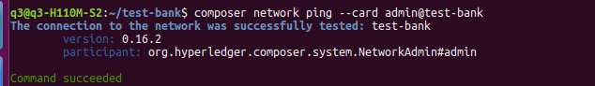

Step Five: Expose a RESTful API
To create a RESTful API from your command line, run the following command:
composer-rest-server

This will shoot a lot of questions.
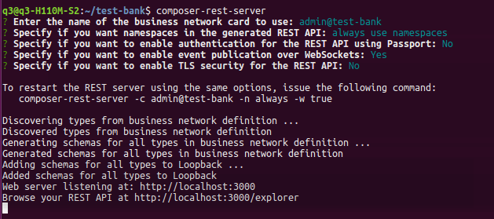
Now point your browser to http://localhost:3000/explorer
You’ll see your beautiful blockchain API.
